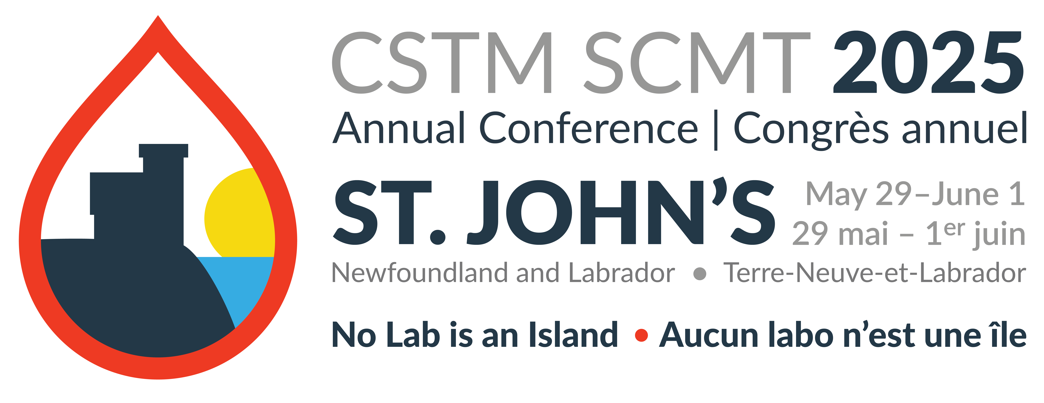

October 21, 2024

Dear Sponsor/Exhibitor,

As a non-profit, multidisciplinary society dedicated to advancing and promoting best practices in Canadian Transfusion Medicine, and in order to regularly meet its mandate, The Canadian Society for Transfusion Medicine (CSTM) holds an annual national conference in different cities across Canada. This event gathers hundreds of professionals providing opportunities for continuing education, communication, networking and building industry partnerships.

In 2025, the conference will be held in St. John’s, Newfoundland from May 29th to June 1st .

The theme of the 2025 Annual Conference is “No Lab is an Island”. We would like to invite you to partner with us in the success of this event where you can help promote advances in the field of transfusion medicine and create partnerships with major key players.

Our attendees include technologists, administrators, physicians, and nurses from hospitals, provincial blood offices, Canadian Blood Services, and Héma-Québec.

We are pleased to offer you the following Sponsorship and Exhibition opportunities:

● Platinum – Sponsorship of $25,000
● Gold – Sponsorship of $20,000
● Silver – Sponsorship of $15,000
● Bronze – Sponsorship of $7,500
● Exhibit space: $ 3,500

We will be following up with you with more details.

In the meantime, if you have any questions, please do not hesitate to contact our Sponsorship Committee at:1-905-928-0538

Respectfully yours,

SScheuermann
Sheena Scheuermann

CSTM Sponsorship Benefits Package

Platinum sponsor Benefits ($25,000)

- Provides an opportunity to sponsor a CSTM Award or Bursary
- Award/bursary may be presented by corporate representative at the CSTM conference during a plenary session
- Award recipient bios with statement about who sponsored the award posted on the CSTM website for a minimum of 5 years, announced in the CSTM newsletter, and included in the conference program.
- Opportunity to host an event on Corporate Night (Saturday evening of the conference)
- One promotional insert in delegate package (to be provided by sponsor)
- One promotional item in delegate package (to be provided by sponsor)
- 1st priority group for choice of booth location and discounted booth cost (40% savings)
- 2 complimentary exhibitor registrations for company booth representatives for sponsors who purchase exhibit booth space.
- 3 complimentary full conference registrations (includes access to educational sessions)
Website presence (April 2025 – March 2026):
- Sponsorship acknowledged on Conference page of the CSTM website
- Sponsorship acknowledged in the CSTM Newsletter, including the Communique website page
- Corporate logo, linked to your corporate website, on CSTM corporate website dedicated conference sponsor page
- Corporate logo, company description, listing of company representatives attending the conference, and link to corporate website on the CSTM conference website and app
Social media presence (April 2025 – March 2026):
- Monthly opportunity for CSTM to share a post on CSTM social media channels (eg, retweet) (12 months)
- Survey opportunity to CSTM members
- Sponsored social media post (3 instances)

Mailing List
- Opportunity for dedicated education event/webinar email to CSTM Members (no product advertising) (3 instances)
- Sponsorship knowledged in the CSTM Newsletter, (12 per year)

Gold sponsor Benefits ($20,000)

- Provides an opportunity to sponsor a CSTM Bursary
- Bursary will be presented at the CSTM Annual General Meeting
- Bursary recipients and sponsors posted on the CSTM website, announced in the CSTM newsletter, and included in the conference program
- Opportunity to host an event on Corporate Night (Saturday evening of the conference)
- One promotional insert or promotional item in delegate package (to be provided by sponsor)
- 2nd priority group for choice of booth location for sponsors who purchase exhibit booth space
- 2 complimentary exhibitor registrations for company booth representatives for sponsors who purchase exhibit booth space.
- 2 complimentary full conference registrations (includes access to educational sessions)
Website presence (April 2025 – March 2026):
- Sponsorship acknowledged on the Conference page of the CSTM website
- Sponsorship acknowledged in the CSTM Newsletter, including the Communique website page
- Corporate logo, linked to your corporate website, on CSTM corporate website dedicated conference sponsor page
- Corporate logo, company description, listing of company representatives attending the conference, and link to corporate website on the CSTM conference website and app
Social media presence (April 2025 – March 2026):
- Monthly opportunity for CSTM to share a post on CSTM social media channels (eg, retweet) (12 months) Subject to CSTM Board Approval
- Survey opportunity to CSTM members
- Sponsored social media post (2 instances)

Mailing List
- Opportunity for dedicated education event/webinar email to CSTM Members (no product advertising) (2 instances)
- Sponsorship acknowledged in the CSTM Newsletter, (12 per year)

Silver sponsorship Benefits ($15,000)

- One promotional insert or promotional item in delegate package (to be provided by sponsor)
- 3rd priority group for choice of booth location for sponsors who purchase exhibit booth space
- 2 complimentary exhibitor registrations for company booth representatives for sponsors who purchase exhibit booth space.
- 1 additional full complimentary registration to the conference

Website presence (April 2025 – March 2026):
- Sponsorship acknowledged on Conference page of the CSTM website
- Sponsorship acknowledged in the CSTM Newsletter, including the Communique website page
- Corporate logo, linked to your corporate website, on CSTM corporate website dedicated conference sponsor page
- Corporate logo, company description, listing of company representatives attending the conference, and link to corporate website on the CSTM conference website and app
Social media presence (April 2025 – March 2026):
- Monthly opportunity for CSTM to share a post on CSTM social media channels (eg, retweet) (12 months) Subject to CSTM Board Approval
- Survey opportunity to CSTM members
- Sponsored social media post (1 instances)

Mailing List
- Opportunity for dedicated education event/webinar email to CSTM Members (no product advertising) (1 instances)
- Sponsorship acknowledged in the CSTM Newsletter, (12 per year)

Bronze sponsorship Benefits ($7,500)

- 4th priority group for choice of booth location for sponsors who purchase exhibit booth space
- 2 complimentary exhibitor registrations for company booth representatives for sponsors who purchase exhibit booth space or 1 complimentary registration to the full conference

Website presence (April 2025 – March 2026):
- Sponsorship acknowledged on Conference page of the CSTM website
- Sponsorship acknowledged in the CSTM Newsletter, including the Communique website page
- Corporate logo, linked to your corporate website, on CSTM corporate website dedicated conference sponsor page
- Corporate logo, company description, listing of company representatives attending the conference, and link to corporate website on the CSTM conference website and app
Social media presence (April 2025 – March 2026):
- Monthly opportunity for CSTM to share a post on CSTM social media channels (eg, retweet) (12 months) Subject to CSTM Board Approval

Mailing List
- Sponsorship acknowledged in the CSTM Newsletter, (12 per year)

EXHIBITORS ($ 3,500)

▪ Booth space allocations will be assigned on a first come, first-served basis, with priority given to sponsors, based on their sponsorship level.

▪ Sponsorship benefits and booth space selections will commence in April 2023 or once payment has been received.

- Corporate logo, linked to your corporate website, on CSTM corporate website on the dedicated conference exhibitor page

▪ Corporate logo, company description, listing of company representatives attending the conference, and link to corporate website on the CSTM conference website and app.

▪ Lead retrieval functionality will be available to exhibitors using the CSTM conference app.

▪ Company representatives may schedule appointments/meetings with attendees via the CSTM conference app.

▪ Booth includes 2 complimentary exhibitor registration for company booth representatives, skirted table, 2 chairs, draped back and side walls.

Sponsorship Form

SPONSORSHIP INFORMATION

Company:
Company Contact:
Address:

City/Province: Postal Code:
Telephone #: Fax #:
E-mail address:

SPONSORSHIP LEVEL

- Platinum – Sponsorship of $25,000 $ Amount
- Gold – Sponsorship of $20,000 $ Amount
- Silver – Sponsorship of $15,000 $ Amount
- Bronze– Sponsorship of $7,500 $ Amount

EXHIBIT SPACE

- Exhibit Space $ 3,500 Quantity: _____ $ Amount
- Exhibit Space for Platinum Sponsors
Cost per space $2,100 Quantity: _____ $ Amount

Please email completed form to sanders@mcmaster.ca and you will be contacted to make payment arrangements.

